ADVANCED SOFTWARE SERVICES, INC
WAREHOUSE MANAGEMENT USER MANUAL

Title Page

Table of Contents 1
Function Keys 2
Warehouse Management Overview 3
Customer Plant Receipts 4
Customer Plant Usage 5
Customer Inventory Reorder Report Screen 6
Customer Inventory Reorder Report – Report 1- Printout Report 7
Customer Inventory Reorder Report – Report 2 8
Customer Inventory Reorder Report – Report 2 - Printout Report 9
Red Flag Report 10
Red Flag Report - Printout Report 11
Usage Post – Exceptions Report 12
Usage Post – Printout Report 13
File Maintence Item 14
Plant File Maintenance – Browser 15
Plant File Maintenance - View Plant 16
Vendor Cross reference File Maintenance 17
Vendor Cross Reference File Maintenance – View Vendor 18
Warehouse History – Browse History 19
Warehouse History – View History 20
Cuastomer Inventory 21

WAREHOUSE MANAGEMENT
FUNCTION KEYS

The following describes the standard function buttons which can be activated with the mouse or the alternate key on your keyboard.

BRWS = The browser folder is a list of records in the file. This is functionally equivalent
to the find option of our standard package.

VIEW = View folder records provides the ability to ADD, CHANGE, DELETE and UPDATE
an individual records.

This effectively replaces the find feature of our legacy Foldware and Corrware products.

SORT BY = The selections at the bottom of the browser which will sort the list in alphabetic order.

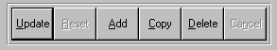

Update = Updating the current record.
Reset = Reset the current record.
Add = Add a record.
Copy = This will copy the existing record.
Delete = Delete the current record displayed on the screen. To delete an individual field, double
click on the field and press the regular delete key on the keyboard.
Cancel = Canceling the information that was entered.
Save = Save the record.


 |  |  |  |  |  |  |  |  |  |  |  |  |  |  |  |  |  |  | First – Takes you to the first record
 |  |  |  |  |  |  |  |  |  |  |  |  |  |  |  |  |  |  | Previous – Takes you back one record at a time
 |  |  |  |  |  |  |  |  |  |  |  |  |  |  |  |  |  |  | Next – Moves forward one record
 | First |  |  | Previous |  |  |  |  | Next |  |  | Last |  |  |  |  |  |  | Last – Last current record
 |  |  |  |  |  |  |  |  |  |  |  |  |  |  |  |  |  |  |  |  | F2 – Search for a record
 |  |  |  |  |  |  |  |  |  |  |  |  |  |  |  |  |  |  |  |  | F3 – List a record
 |  |  |  |  |  |  |  |  |  |  |  |  |  |  |  |  |  |  |  |  | F4 – Add notes to a record
 |  |  |  |  |  |  |  |  |  |  |  |  |  |  |  |  |  |  |  |  | F5 – Misc. fields
F2 |  |  | F3 |  | F4 |  | F5 |  |  | F6 |  |  | F7 |  |  | F8 | F9 | F12 |  |  | F6 – Browse the records
 |  |  |  |  |  |  |  |  |  |  |  |  |  |  |  |  |  |  |  |  | F7– View the records
 |  |  |  |  |  |  |  |  |  |  |  |  |  |  |  |  |  |  |  |  | F8 – Phone Information
 |  |  |  |  |  |  |  |  |  |  |  |  |  |  |  |  |  |  |  |  | F9 – Addressees
 |  |  |  |  |  |  |  |  |  |  |  |  |  |  |  |  |  |  |  |  | F12 – Exit the screen

ADVANCED SOFTWARE SERVICES, INC
WAREHOUSE MANAGEMENT OVERVIEW

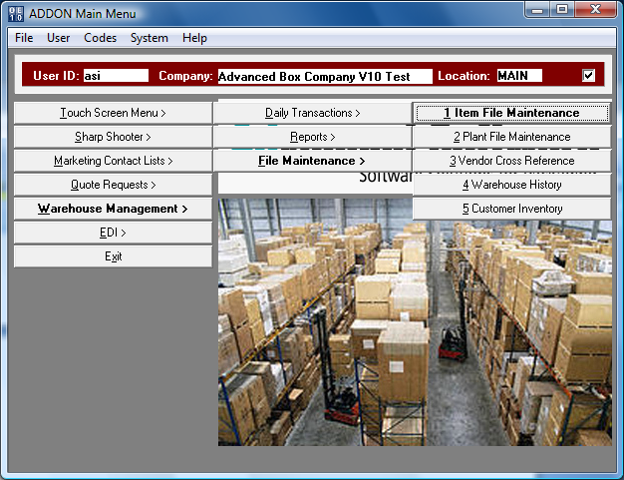

Keeping inventory management costs down is crucial to competitive advantage. Advanced Software’s Warehouse Management module helps cut inventory costs by providing tighter control of stock levels at the customers plant.

ADVANCED SOFTWARE SERVICES, INC
CUSTOMER PLANT RECEIPT

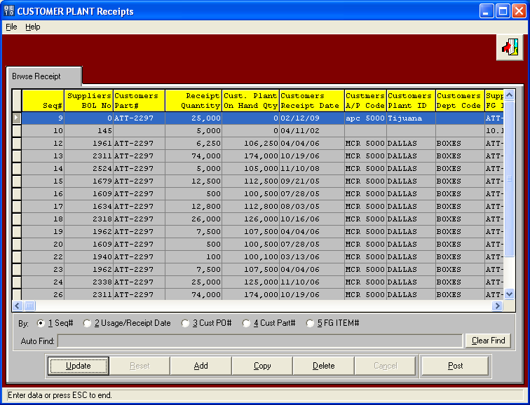

This data entry sceens tracks the customers receipts of an finished goods items, thereby increasing the on hand quantity of finished goods at the customer plant or warehouse location. Clients and email an excel spreadsheet or they can login over the internet via ASI ANYWARE or your customer service personnel can update the data via this data entry screen. If you enter the Advantzware bill of lading number, the quantities shipped will be added to the transaction screen. Of course, the valid warehouse / plant ID must be entered.

ADVANCED SOFTWARE SERVICES, INC
CUSTOMER PLANT CONSUMPTION

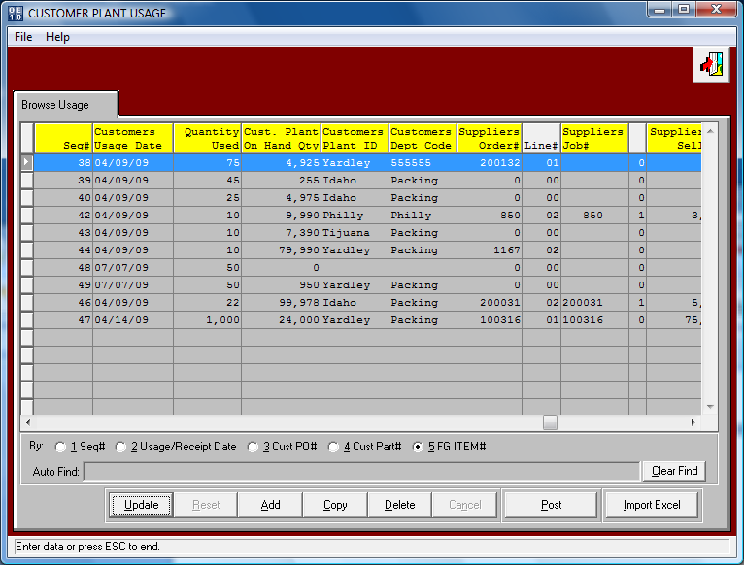

This data entry sceens tracks the customers useage of an item, therefore reduces the on hand quantity at the customer plant or warehouse location. Clients and email an excel spreadsheet with the useage or they can login over the internet via ASI ANYWARE or your customer service personnel can update the data via this data entry screen. Of course, the valid warehouse / plant ID must be entered.

ADVANCED SOFTWARE SERVICES, INC
CUSTOMER INVENTORY REORDER REPORT - REPORT 1

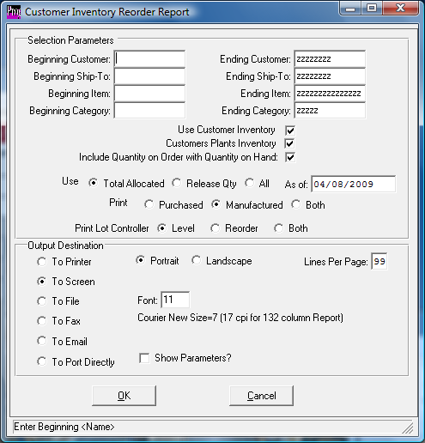

In general, Advantzware houses the inventory of boxes for the box manufacturer. For example, Advanced Packaging Corp (APC) gets order for 100,000 8x8x8 boxes from IBM Corp. APC produces 110,000, the APC inventory on Hand shows 110,000. If APC ships 50,000 boxes, then the APC inventory shows 60,000 on hand. However, IBM now has 50,000 on hand. This module keeps track of IBM's inventory. If IBM uses 25,000 this module as data entry to record that transaction. If IBM wants to know how much inventory do they have. The report will show IBM with 25,000 and APC with 60,000. This is compared to a Reorder Level to see if IBM needs to reorder more boxes.

For example, item 8x8x8 has reorder level of 75.000 boxes. If APC did not have the Warehouse Management Report.
The inventory I-R-2 report in Advantzware would only show 60,000 on hand. Since 60,000 is less than 75,000 the I-R-1 Reorder Advise Report would say to Produce more 8x8x8 boxes. However if APC owned the Warehouse Management Module. Then APC has 60,000, IBM still has 25,000 so total inventory = 85,000. Since 85,000 is greater than 75,000, the Reorder Advise Report in Warehouse Management would no show 8x8x8. Hence, 8x8x8 would not require another order or job.

ADVANCED SOFTWARE SERVICES, INC
CUSTOMER INVENTORY REORDER REPORT - REPORT 1

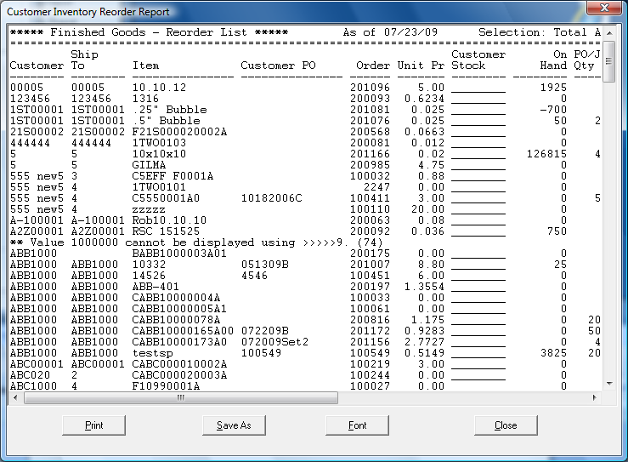

ADVANCED SOFTWARE SERVICES, INC
CUSTOMER INVENTORY REORDER REPORT - REPORT 2

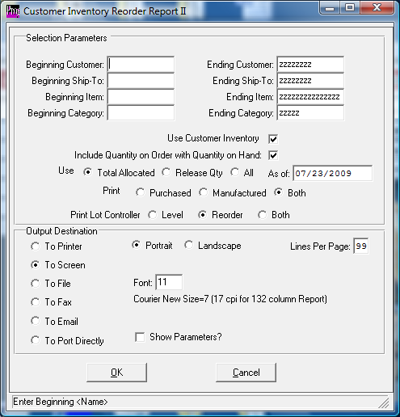

In general, Advantzware houses the inventory of boxes for the box manufacturer. For example, Advanced Packaging Corp (APC) gets order for 100,000 8x8x8 boxes from IBM Corp. APC produces 110,000, the APC inventory on Hand shows 110,000. If APC ships 50,000 boxes, then the APC inventory shows 60,000 on hand. However, IBM now has 50,000 on hand. This module keeps track of IBM's inventory. If IBM uses 25,000 this module as data entry to record that transaction. If IBM wants to know how much inventory do they have. The report will show IBM with 25,000 and APC with 60,000. This is compared to a Reorder Level to see if IBM needs to reorder more boxes.

For example, item 8x8x8 has reorder level of 75.000 boxes. If APC did not have the Warehouse Management Report.
The inventory I-R-2 report in Advantzware would only show 60,000 on hand. Since 60,000 is less than 75,000 the I-R-1 Reorder Advise Report would say to Produce more 8x8x8 boxes. However if APC owned the Warehouse Management Module. Then APC has 60,000, IBM still has 25,000 so total inventory = 85,000. Since 85,000 is greater than 75,000, the Reorder Advise Report in Warehouse Management would no show 8x8x8. Hence, 8x8x8 would not require another order or job.

ADVANCED SOFTWARE SERVICES, INC
CUSTOMER INVENTORY REORDER REPORT - REPORT 2

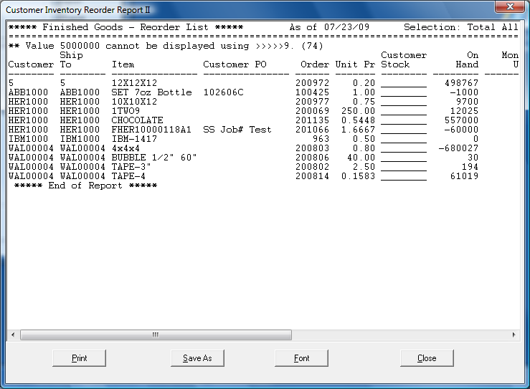

ADVANCED SOFTWARE SERVICES, INC
CUSTOMER INVENTORY REORDER REPORT - RED FLAG REPORT

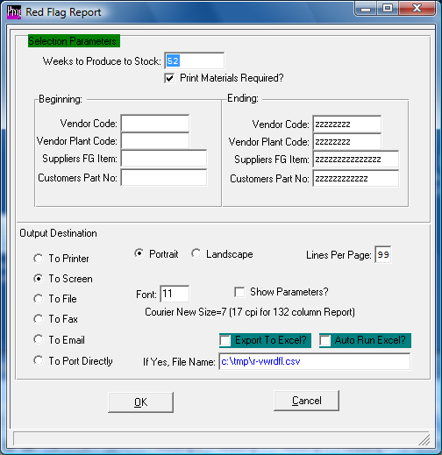

Monthly Usage = Annual Useage divided by 12 months Report Prints by Range of DIE#
1) Customer Part#
2) Previous Order Number (Last order Number?)
3) Plant Code defined on Vendor Managed Warehouse Database.
4) Annual Usage = Qty of Expected Annual Boxes to Manufacture
5) Line# = O-U-1 has field call Line# that can be changed.
6) HOP / CAVIDODES = Die Number Up from Estimate
7) Weeks in Inventory = I-F-2 Inventory + Addon Customer Inventory = Total Inventory On Hand
EAU Divided by 52 = Weekly Usage
Weeks in Inventory = Total Inventory On Hand / Weekly Usage
8) Need to Produce = Screen Heading No of Weeks of Inventory for Safety Stock Level? 999
Number of Weeks X (Annual Useage / 52) minus On Hand Inventory (I-R-2 + Customer)
9) Producing = Prompt for Field called Quantity to Produce
10) New Weeks In Inventory = Total of weeks of inventory on hand after the production run.
Hence. On hand via I-R-2 plus Plant + Producing / Monthly Useage
11) Colors Import from our Estimating Software from Total Colors for the item
12) Price = Sell Price from O-U-1
13) Board Grade, all part numbers that are in the same Ref Pk share the same Board Grade.
14) Board Size, is the sheet size of the cutting die that that particular Ref Pk runs in.
15) Material= Board Grade (caliper and material, SBS, CCNB)
16) Cant. Material: Quantity of material needed to run this red flag (in sheets)
17) Costo de Material: It's the cost of the Board Material to produce this red flag.
Grand Totals to print from LAYOUT folder of estimate.
Board Code, Board Descripiton, Sheet Width, Sheet Length, Total Sheets (Total Qty/#Up)
Total Cost of Sheets Sheets X Cost from Vendor Cost Matrix of RM item File.
ADVANCED SOFTWARE SERVICES, INC
CUSTOMER INVENTORY REORDER REPORT - RED FLAG REPORT

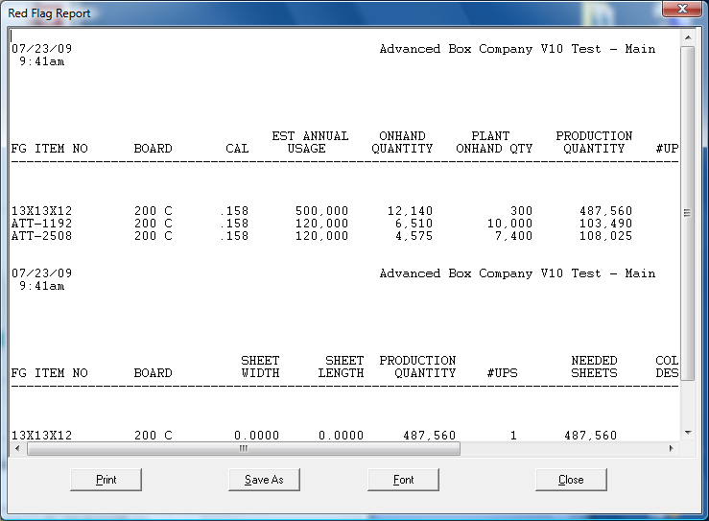

ADVANCED SOFTWARE SERVICES, INC
CUSTOMER INVENTORY REORDER REPORT – EXCEPTIONS REPORT

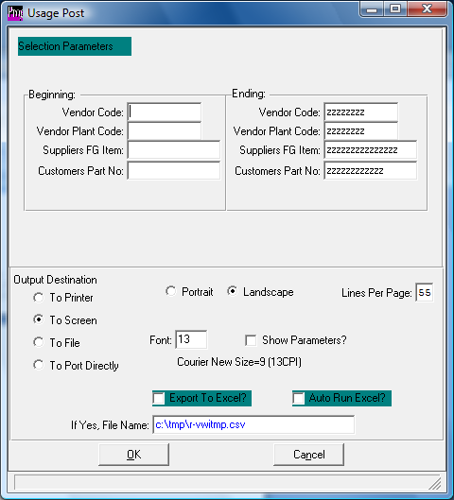

ADVANCED SOFTWARE SERVICES, INC
CUSTOMER INVENTORY REORDER REPORT – EXCEPTIONS REPORT

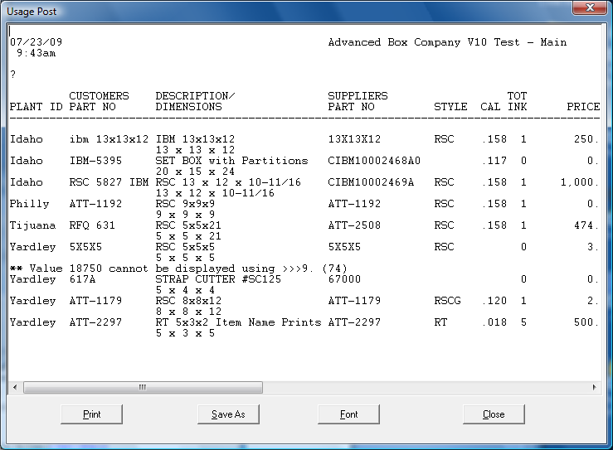

ADVANCED SOFTWARE SERVICES, INC
FILE MAINTENANCE ITEM

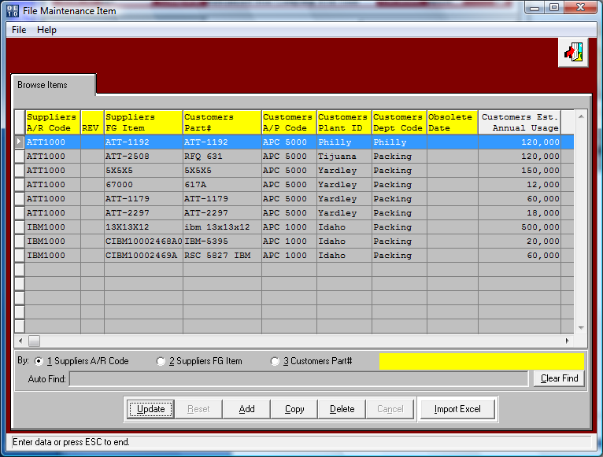

This data entry sceens provides the initial building of the customers finished goods items including the on hand quantity, annual useage consumption of this item, part number the box suppliers finished goods item code, department code, customer code, warehouse and plant ID and more.

ADVANCED SOFTWARE SERVICES, INC
PLANT FILE MAINTENANCE – BROWSE PLANT

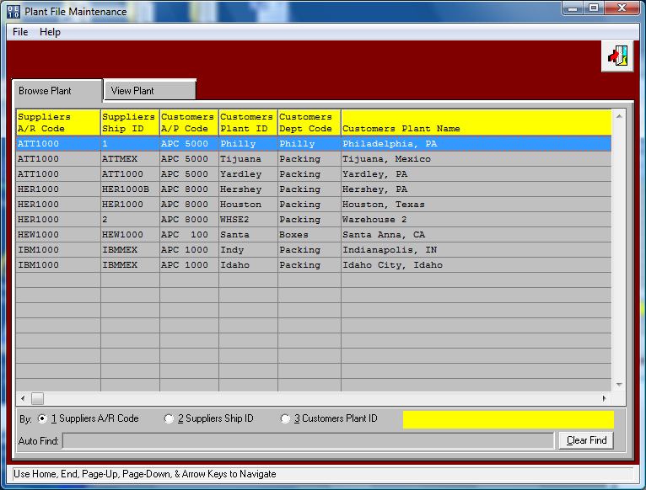

This data entry sceens provides the initial building of the customers warehouse and plant IDs. This also is the cross reference file for the customer code given by the box manufacture as well as the vendor code given by the customer.
In other words, the customer has a software program with a vendor file that they give the box manufacture a vendor code.
Likewise, the boxmaker has an accounts receivable customer file that must define a customer code and shipto code for the customers plant or warehouse ID. This file allows the plant receipt and useage programs to validate the shipto code on the bill of lading with the customers plant ID. Likewise, the customers vendor ID for the box manufacture is defined in this file so that the Customers Warehouse Reports print the Plant ID and Vendor ID that their software uses.

Bottom line, we must synchronize the Advantzware software with your customers software so that the reports are friendly to your customer.

ADVANCED SOFTWARE SERVICES, INC
PLANT FILE MAINTENANCE – VIEW PLANT

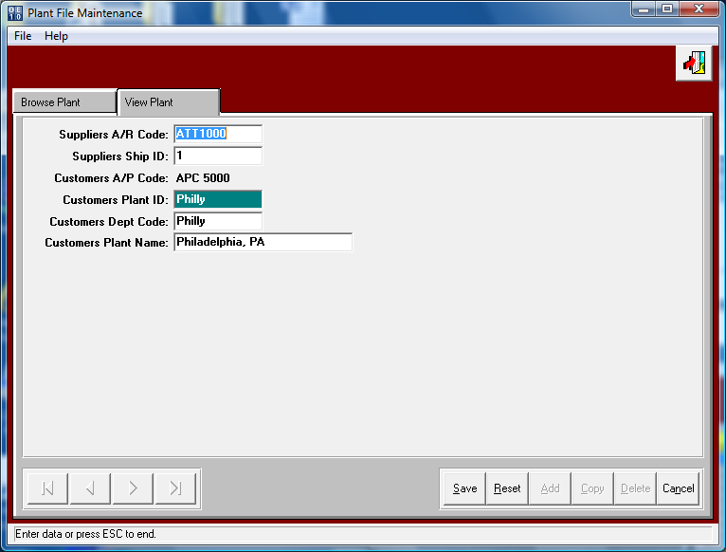

This data entry sceens provides the initial building of the customers warehouse and plant IDs. This also is the cross reference file for the customer code given by the box manufacture as well as the vendor code given by the customer.
In other words, the customer has a software program with a vendor file that they give the box manufacture a vendor code.
Likewise, the boxmaker has an accounts receivable customer file that must define a customer code and shipto code for the customers plant or warehouse ID. This file allows the plant receipt and useage programs to validate the shipto code on the bill of lading with the customers plant ID. Likewise, the customers vendor ID for the box manufacture is defined in this file so that the Customers Warehouse Reports print the Plant ID and Vendor ID that their software uses.

Bottom line, we must synchronize the Advantzware software with your customers software so that the reports are friendly to your customer.

ADVANCED SOFTWARE SERVICES, INC
VENDOR CROSS REFERENCE FILE MAINTENANCE – BROWSE VENDOR

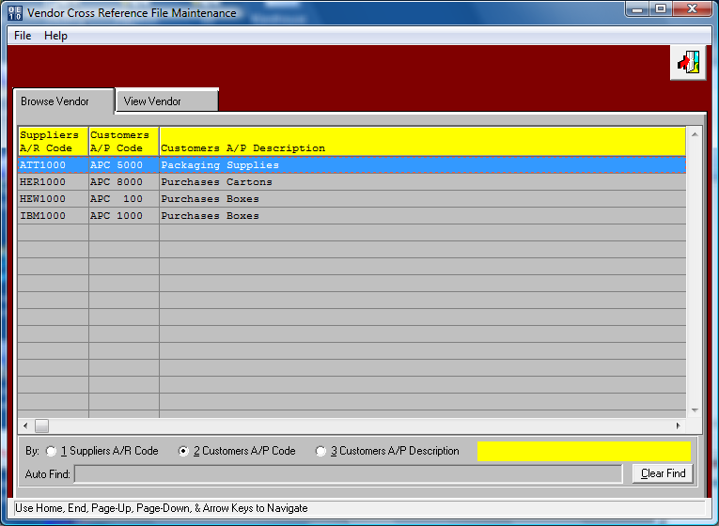

This data entry sceens provides the initial building of the customers warehouse and plant IDs. This also is the cross reference file for the customer code given by the box manufacture as well as the vendor code given by the customer.
In other words, the customer has a software program with a vendor file that they give the box manufacture a vendor code.
Likewise, the boxmaker has an accounts receivable customer file that must define a customer code and shipto code for the customers plant or warehouse ID. This file allows the plant receipt and useage programs to validate the shipto code on the bill of lading with the customers plant ID. Likewise, the customers vendor ID for the box manufacture is defined in this file so that the Customers Warehouse Reports print the Plant ID and Vendor ID that their software uses.

Bottom line, we must synchronize the Advantzware software with your customers software so that the reports are friendly to your customer.

ADVANCED SOFTWARE SERVICES, INC
VENDOR CROSS REFERENCE FILE MAINTENANCE – VIEW VENDOR

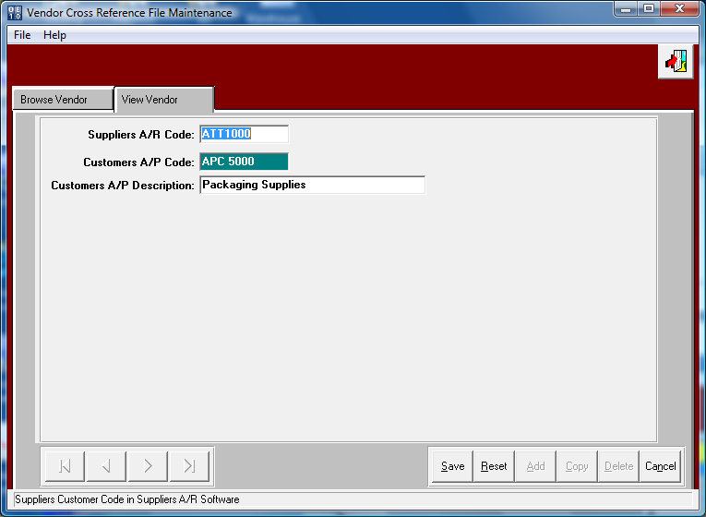

This data entry sceens provides the initial building of the customers warehouse and plant IDs. This also is the cross reference file for the customer code given by the box manufacture as well as the vendor code given by the customer.
In other words, the customer has a software program with a vendor file that they give the box manufacture a vendor code.
Likewise, the boxmaker has an accounts receivable customer file that must define a customer code and shipto code for the customers plant or warehouse ID. This file allows the plant receipt and useage programs to validate the shipto code on the bill of lading with the customers plant ID. Likewise, the customers vendor ID for the box manufacture is defined in this file so that the Customers Warehouse Reports print the Plant ID and Vendor ID that their software uses.

Bottom line, we must synchronize the Advantzware software with your customers software so that the reports are friendly to your customer.

ADVANCED SOFTWARE SERVICES, INC
WAREHOUSE HISTORY – BROWSE HISTORY

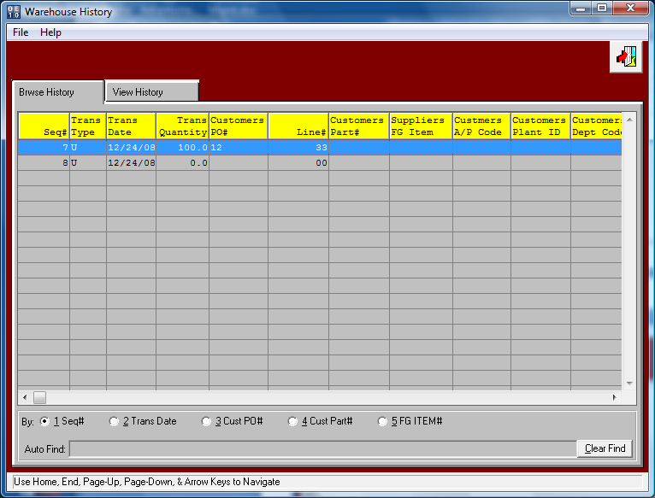

This file provides a history of all transactions recorded for each finished goods item number.
The browser allows quick search by Sequence number, Transaction date, Customer Purchase Order Number, Customer Part Number and Finished Goods Item Code.

ADVANCED SOFTWARE SERVICES, INC
WAREHOUSE HISTORY – VIEW HISTORY

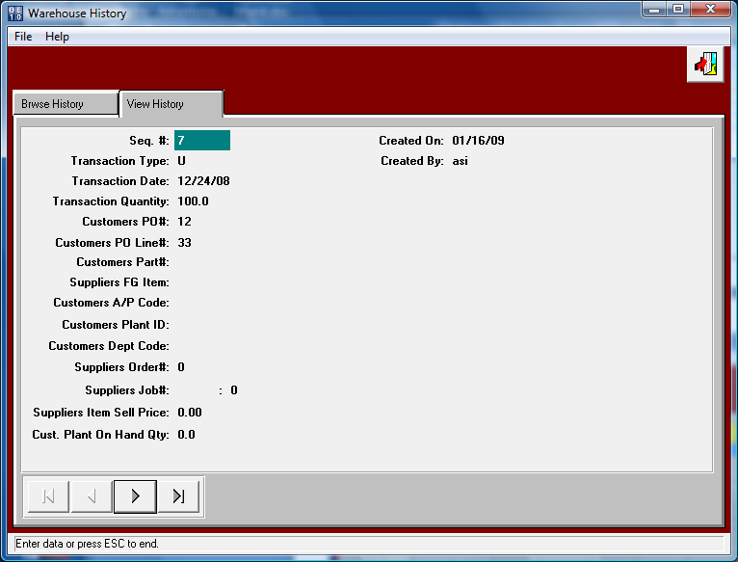

This file provides a history of all transactions recorded for each finished goods item number.

ADVANCED SOFTWARE SERVICES, INC
CUSTOMER INVENTORY – CUSTOMER INV

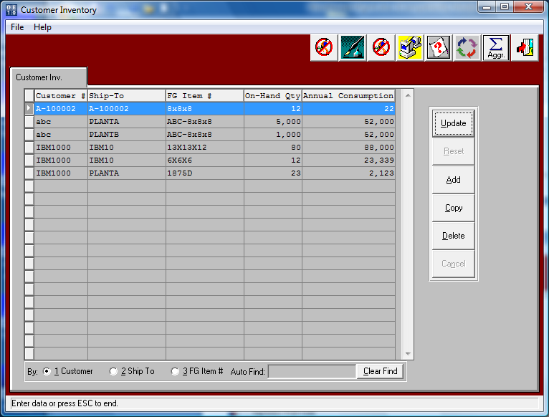

This is the Older Version of the Warehouse Management Software

